Safety Subscription
Employee Training
Hazard Communication Standard
Become Familiar with the Rule
The Hazard Communication Standard (HCS) is based on a simple concept -that employees have both a need and a right to know the hazards and identities of the chemicals they are exposed to when working. They also need to know what protective measures are available to prevent adverse effects from occurring. The HCS (29 CFR 1910.1200) is designed to provide employees with the information they need.

In fact, the Hazard Communication Standard (HCS) has always been the rule that requires employers to provide training and chemical hazard information to their employees. The requirement of maintaining an inventory and the material safety data sheets (MSDS/SDS) for chemical found in the workplace is the most commonly know portion of the rule. Having a Safety Supervisor, MSDSs, monthly training and a written Safety Plan (or Hazard Communication Program) makes up the rule.

Under the provisions of the Hazard Communication Standard, employers are responsible for informing employees of the hazards and the identities of workplace chemicals to which they are exposed. Recently the United States agreed to the Globally Harmonized System (GHS) of Classification and Labeling of Chemicals. This simply means that the Safety Data Sheet (SDS) for chemicals will be formatted in the agreed United Nation’s standard look but in the native language in all nations across the globe.

Last year, by December 1, 2013, all employers subject to the Hazard Communication Standard were required to review the changes and the conversion to GHS with their employees. Training is also required ANNUALLY. This training material will meet your need.

Identify Responsible Staff
Simply stated this is the Safety Supervisor. Hazard Communication is an ongoing program in the facility. In order to have a successful program, it is necessary to assign responsibility for both the initial and ongoing activities that have to be undertaken to comply with the rule. For any safety and health program, success depends on commitment and possibly a change in behavior. This will only occur if employers understand the program, and are committed to its success, and if employees are motivated by the people presenting the information to them.

Identify Hazardous Chemicals in the Workplace
The Standard requires a list of hazardous chemicals in the workplace as part of the written hazard communication program. The list will serve as an inventory of everything for which a MSDS must be maintained.

The best way to prepare a comprehensive list is to survey the workplace. Purchasing records may also help. Employers should establish purchasing procedures that result in MSDSs being received before a material is used in the workplace. Check your files against the inventory you have just compiled to ensure that an MSDS exists for each potentially hazardous chemical. If any are missing, contact your supplier and request one.

What is new is the format of the MSDS changing to the globally harmonized system or GHS standard and becoming known as Safety Data Sheets or SDS which look similar to MSDS and contain the same information but will uniformly convey that information in all languages augmented by the use of universally accepted hazard pictograms.
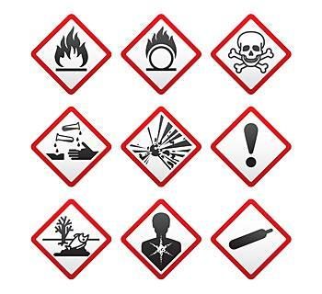

Preparing and Implementing a Hazard Communication Program
All workplaces where employees are exposed to hazardous chemicals must have a written plan which describes how the standard will be implemented in that facility. The plan does not have to be lengthy or complicated. It is intended to be a blueprint for implementation of your program--an assurance that all aspects of the requirements have been addressed.

Add the facility specific information and the name of the Safety Supervisor to the template plan provided here. Add any additional site specific information to the plan and keep a copy of this written plan in the MSDS binder or readily available in case of an OSHA inspection.

Use the attached training material to conduct Employee Awareness Training on HCS, GHS and the new SDS format including the pictograms and labels that will be used on drums, totes and tanks in the shop. Show the Label example and the written Haz Comm Program during training. Display the SDS Binder if possible.

MSDS Library
http://www.sueschauls.com/MSDS.html

The MSDS Library at SueSchauls.com contains the Material Safety Data Sheets (MSDS) for all fluids that are evacuated from salvage vehicles plus some commonly used products. Check out the SDS for Gasoline to see the new format! The resource is available to all automotive facilities to help facilitate a comprehensive Safety Program. In the coming months and years through June 2016 when the conversion from MSDS to SDS is complete this library will be updated as SDS become available for automotive fluids and products.

Review and update your SDS Inventory annually and on an ongoing basis. One of the best housekeeping jobs that can be conducted at the yard is to rid shelves of unused products especially those that have pulled out of a vehicle and are just collecting dust. Pre-loaded safety binders are also available just call Sue at 319-290-7843 or email Schauls3@mchsi.com.

HAZARD COMMUNICATION PROGRAM

In compliance with 29 CFR 1910.1200, OSHA's Hazard Communication Standard, this written hazard communication program has been established for

___________________________________________ (INSERT COMPANY NAME HERE).

__________________________________________________________________________
(INSERT NAME OF SAFETY SUPEVISOR & JOB TITLE HERE)

is designated as the Hazard Communication Program Coordinator Safety Supervisor responsible for seeing that all aspects of the program are carried out in the fashion intended. A copy of the program will be available for review by all employees.

- HAZARD DETERMINATION PROCEDURES. We will rely upon the manufacturer/supplier to evaluate the hazards of the chemicals they supply to us and communicate that information via the Safety Data Sheet. The Safety Supervisor will review the information on the SDS.
  - The Safety Supervisor will review each SDS sheet when received to see that it contains the required information and has no blank spaces.
  - The Safety Supervisor will write to the supplier for any missing information or find the SDS online for download. If the supplier will not respond within 30 days or if the SDS cannot be located:
    - Purchasing Department will find a new supplier or product. (A complaint can be filed against the supplier at the local OSHA Office).
  - The Safety Supervisor will retain the original in a Master SDS Book which is kept at the facility.
  - Updated SDS will replace older versions as they become available.

- LIST OF HAZARDOUS CHEMICALS. An inventory of hazardous materials used at the facility for which there must be Material Safety Data Sheet is listed at the front of the SDS/Safety binder. Any new chemical intended to be purchased will be reviewed by the Safety Supervisor to see if an SDS is needed. Purchasing will automatically request a copy of the SDS at time of purchase. Upon receipt, the SDS will be placed in the SDS binder.

- PROCEDURES -LABELS AND OTHER FORMS OF WARNING. All containers in the workplace are to be labeled in order to provide an immediate visual warning about the hazards of the chemical in the container. The Safety Supervisor is responsible for ensuring that all containers are labeled.
  - Since chemical manufacturers are required to label their containers, we use those already present labels as our primary means of labeling.
  - If chemicals covered under this program are transferred from the original shipping container to another container for an employee's use, those containers will be labeled with a secondary label. Our secondary or back-up labeling system will consist of using a label similar to the label supplied by the vendor. This will assist employees in easily identifying the product involved with less chance of error.
  - The Safety Supervisor will ensure that all containers of chemicals are correctly labeled at the time they are received in the facility. The supervisor will check to make sure that the container is clearly labeled as to its contents and has the appropriate hazard warnings. Any container which does not have this information may be returned to the supplier at the supplier's expense.
  - Employees will be reminded that labels are not removed from any container or defaced in any manner.
  - Empty containers will not be re-used to store other materials unless the container has been cleaned, the old label removed, and a new label affixed in its place.

- PROCEDURES – SAFETY DATA SHEETS. Safety Data Sheets (SDS) for each hazardous chemical in the workplace are readily accessible to employees when they are in the work areas during each work shift.
  - The Safety Supervisor will be responsible for obtaining/maintaining the SDS and will coordinate these efforts with the Purchasing Department.
  - The original or copy of the SDS will be retained in the SDS binder in the work area at all times. Any employee in the work area will have ready access to the SDS.

- TRAINING -PROCEDURES/FORMATS. Employees will be provided with information and training on hazardous chemicals in their work area at the time of their initial assignment and whenever a new hazard is introduced into their work area. This will ensure that employees have the necessary information prior to exposure to prevent the occurrence of adverse health effects. Re-training will be done when a new hazard is introduced into the work area, not a new product.

Every attempt will be made by the company to provide engineering controls or administrative controls to eliminate any hazard to our employees.

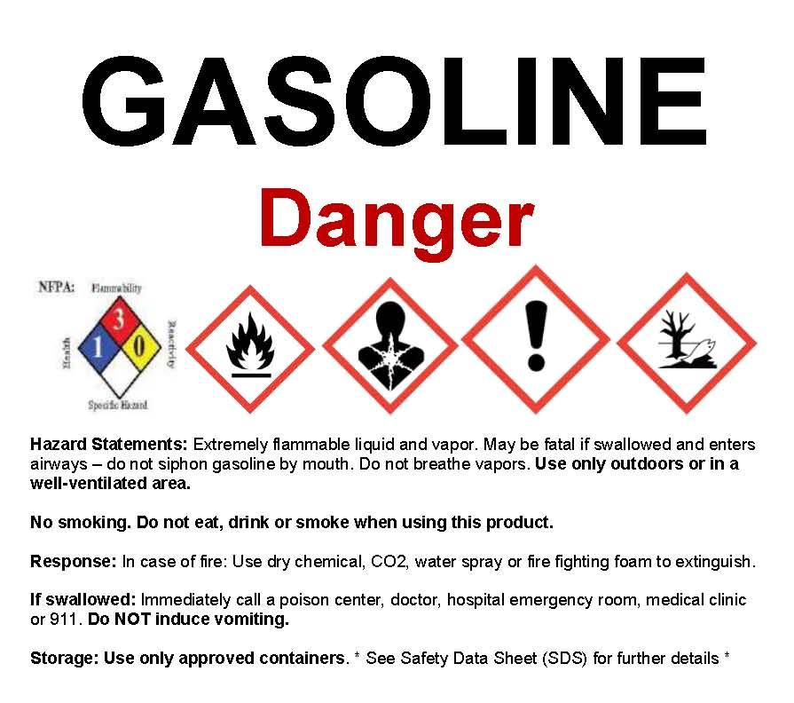
Employee Training

The Hazard Communication Standard or HCS is the OSHA rule designed to inform employees of the hazards and the identities of workplace chemicals to which they are exposed.

A change coming in the U.S. for safety compliance is the Globally Harmonized System (GHS) of Classification and Labeling of Chemicals. This simply means that the material safety data sheet (MSDS) for chemicals will look the same in all nations across the globe. It is the agreed United Nation’s standard.

What is new is the format of the MSDS changing to the global standard and becoming known as Safety Data Sheets or SDS which look similar to MSDS and contain the same information but will uniformly convey that information in all languages augmented by the use of universally accepted hazard pictograms.

A written Hazard Communication Plan has been developed for this facility to ensure the safety of employees by identifying chemical hazards in the workplace and to maintain important information about those chemicals.

A copy of the written plan is available for each employee to review during this training event and at any time desired. A copy is kept in the MSDS binder as discussed below. (SHOW THE SDS BINDER TO EMPLOYEES)

The Hazardous Communication Program has three important components with records of each retained in the MSDS binder:

1) An Inventory list of hazardous chemicals at this salvage yard.
The inventory list of chemicals at the facility is kept in the front of the SDS binder. Employees are asked to help identify products used in the shop that may need an SDS. Everyone must work together to keep each other safe.

2) Safety Data Sheet (SDS) and labels for each hazardous chemical.
An MSDS or SDS is an informational sheet used to communicate hazardous characteristics of chemicals found in the workplace. The MSDS/SDS and container labeling are vital resource for handling those chemicals in an emergency situation. Labels are not removed from any container or defaced in any manner. New SDS compliant labels will be used on products as the GHS format Safety Data Sheet become available.

3) A written hazard communication program.
Employees will be trained on hazardous chemicals in their work
area at the time of their initial assignment and whenever a new hazard is introduced into their work area. This will ensure that employees have the necessary information prior to exposure to prevent the occurrence of adverse health effects. Retraining will
be done when a new hazard is introduced into the work area,
not a new product.
