Hybrid Vehicle Dismantling Guide Highlights

A hybrid electric vehicle works like this:
1) Gasoline is stored in a fuel tank for use in the internal combustion engine.
2) Electricity is stored in a high voltage (HV) battery pack used to power the electric motor(s).
3) One or both sources are used to power the vehicle.

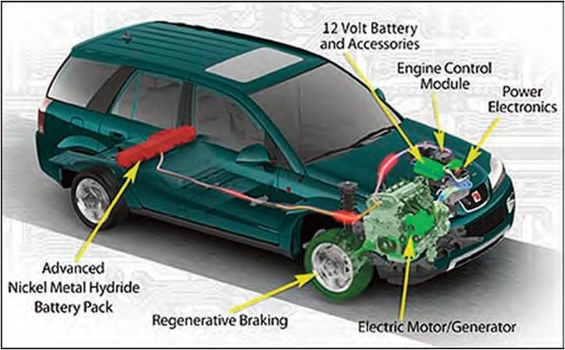

Key terms in HEV technology:
The Continuously Variable Transmission or CVT is located between the gas engine and the electric motor. Honda called it INTEGRATED MOTOR ASSIST or IMA.
REGENERATIVE BRAKING is the vehicle’s ability to use the electric motor as a generator by capturing energy of friction normally lost in braking.

By the end of 2016, J.D. Power expects there to be 159 hybrid and electric vehicle models available for purchase in the U.S. market. This is a significant increase from the 31 models in 2009.

HEV Power Systems
Hybrids are classified by the division of power between sources. Both sources (electric motor and gas engine) may operate in PARALLEL, to simultaneously provide acceleration, or operate in SERIES with one sources exclusively providing the acceleration and the second being used to enhance power. A Series-Parallel system is also possible with one primary power source and the other providing direct additional acceleration if required. Accessories such as power steering and air conditioning are powered by electric motors.

Parallel System
- Most common in HEV.
- Engine and electric motor connected to mechanical transmission.
- Use one electrical motor/generator as second power source and replaces starter & alternator (often located between engine and transmission).

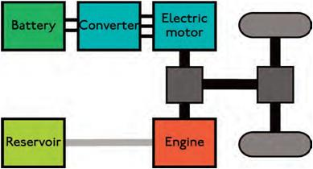

Series System
- Referred to as Range-Extended Electric Vehicles.
- Driven by electric traction.
- The engine drives the generator and not the wheels.
- Electric motor matched to wheels, does not require transmission between engine & wheels.

Types by Degree of Hybridization
FULL Hybrid is a vehicle that can run on just the engine, just the batteries or a combination of both.

MILD Hybrid is basically a conventional vehicle with some degree of hybrid hardware but with limited features.

Hybrid Electric Vehicle Hazards
In addition to usual automotive hazards of flammable gasoline, 12 volt electrical shorts/fires and non-deployed airbags, HEV have high voltage safety issues.
For this reason cables on HEV are either

    - BLUE (42-volt) use CAUTION or
    - ORANGE (60-volt) use EXTREME CAUTION.

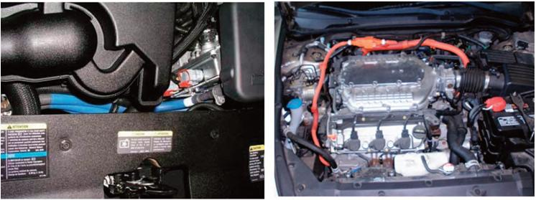

Create a buffer zone of a 3-foot perimeter with caution tape that does not have any metal items in it. Wear insulated gloves such as OSHA-approved “lineman gloves” and use a CAT III Meter.

Hybrid Electric Vehicle Safety Precautions

The right tools are absolutely mandatory:
- Class 0/1000 Volt GLOVES
- CAT III 1000 Volt digital multi meter (DMM)
- Safety Glasses with side shields
- Linesman type high voltage rescue hook
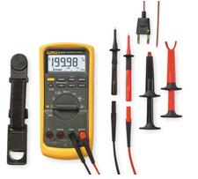

Hybrid Electric Vehicle Service Disconnect Procedures
- Turn off ignition/ press power button off.
- Remove key from vehicle (smart key systems may allow power ups if key is in the vehicle).
- Disconnect 12-volt battery (for added precaution).
- Remove/ switch off OEM HV battery disconnect service device. (DO NOT handle the HV Battery without Class 0/1000 safety gloves!
- Test the part being removed with CAT III/1000 Volt meter.

Anything less than 15 Volts is safe to handle without gloves.

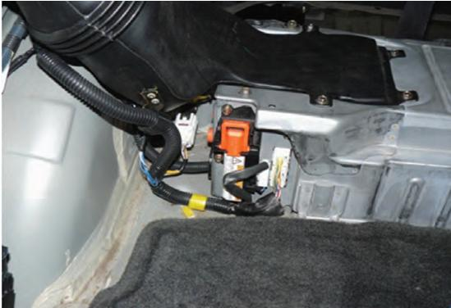

Hybrid Electric Vehicle Dismantling Guide was funded by EPA Grant EPA-OECA-OC-10-01 and CFDA # 66.305 through the Environmental Compliance for Automotive Recyclers (ECAR) compliance assistance center. http://www.ecarcenter.org/

About the author: Sue Schauls is an independent environmental consultant with automotive expertise. She is the Iowa Automotive Recyclers Executive Director & I-CARE Program Manager and the CCAR-Greenlink Technical Advisor.

