The Future Has Arrived

At the recent Automotive Recyclers Association convention I presented the new Hybrid Vehicle Dismantling Guide. The presentation and the guide were the fruition of a two-year project of the ARA Technical Advisory Committee. The project team was made up of Chairman, Chuck Ossenkop, Northwest Auto Parts in Anchorage, Alaska, Betsy Beckwith, the ECAR Center (Environmental Compliance for Automotive Recyclers – http://www.ecarcenter.org) website manager and ARA Government Affairs staffer, and myself, Sue Schauls of the Iowa Automotive Recyclers and the Iowa – Certified Automotive Recyclers Environmental (I-CARE) Program.
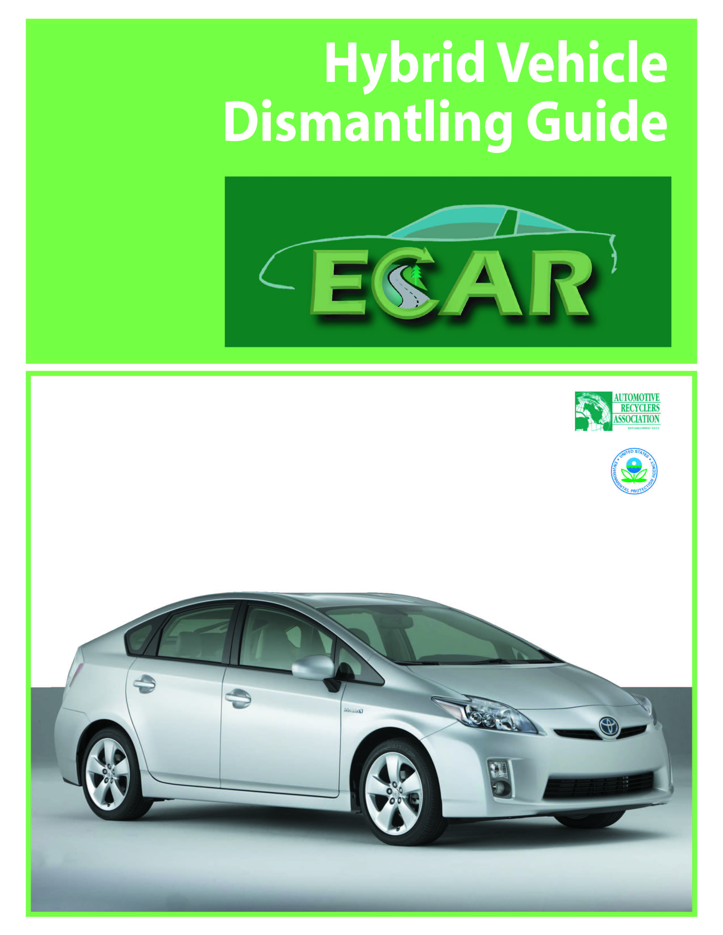

We each presented a portion of the new material with Chuck delivery the very detailed technical stuff. At one point I described the difference between a FULL and a MILD hybrid vehicle.
Basically, a FULL hybrid vehicle is a gasoline and electric powered vehicles that share the task of supplying power to the components and functions of the vehicle. A MILD hybrid vehicle is a typical internal combustion engine car that has integrated hybrid technology into the system such that electronic power controlled units like power steering or air conditioning are now powered by electric motor generators for improved fuel efficiency.
In the future more and more vehicle designs will include the innovative technology born of hybrid design making their way in to conventional vehicles bringing to market more MILD hybrid options. The very next day the October 15th weekend edition of the USA Today featured a story on page 3D about “the new Buick LaCrosse mild hybrid, gas-electric drivetrain for big Buick sedans, priced the same as the V6 gas model, but rated 6 mpg better.” The future has arrived.

About the author: Sue Schauls is an independent environmental consultant with automotive expertise. She is the Iowa Automotive Recyclers Executive Director & I-CARE Program Manager and the CCAR-Greenlink Technical Advisor.

