OSHA Goes Global

OSHA Aligns with United Nations for Globally Harmonized System

The U.S. OSHA has agreed to the United Nation’s standard for Globally Harmonized System (GHS) of Classification and Labeling of Chemicals. This simply means that the material safety data sheet (MSDS) for chemicals will look the same in all nations across the globe. An existing rule called the
Hazard Communication Standard was updated to accommodate the global standardization.

The Hazard Communication Standard has always been the rule that requires employers to provide training and chemical hazard information to their employees. The requirement of maintaining an inventory and the material safety data sheets (MSDS) for chemical found in the workplace is the most commonly know portion of the rule. Having a Safety Supervisor, MSDSs, monthly training and a written Hazard Communication Standard is the gist of the rule.

Training Deadline was December 1, 2013

What is new is the format of the MSDS changing to the global standard and becoming known as Safety Data Sheets or SDS which look similar to MSDS and contain the same information but will uniformly convey that information in all languages augmented by the use of universally accepted hazard pictograms.

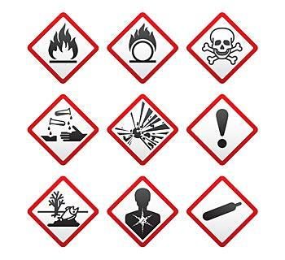

By December 1, 2013, employers that have chemicals in the workplace must train employees on the updated Hazard Communication Standard.

The Hazard Communication Standard (HCS) is based on a simple concept - that employees have both a need and a right to know the hazards and identities of the chemicals they are exposed to when working.

Identify Responsible Staff by designating a Safety Supervisor. Hazard communication is an ongoing program in the facility. In order to have a successful program, it is necessary to assign responsibility for both the initial and ongoing activities that have to be undertaken to comply with the rule.

The Standard requires a list of hazardous chemicals in the workplace as part of the written hazard communication program. The list will serve as an inventory of everything for which a MSDS/SDS must be maintained. The best way to prepare a comprehensive list is to survey the workplace. Purchasing records may also help. Employers should establish purchasing procedures that result in MSDS/SDSs being received before a material is used in the workplace.

Check your files against the inventory of chemicals in the workplace to ensure that an MSDS/SDS exists for each potentially hazardous chemical. If any are missing, contact the supplier and request one. As chemical manufacturers convert their existing MSDSs to GHS SDS format, GHS labels will accompany these new SDSs.

Begin using the term HAZARD COMMUNICATION STANDARD along with the more familiar MSDS.
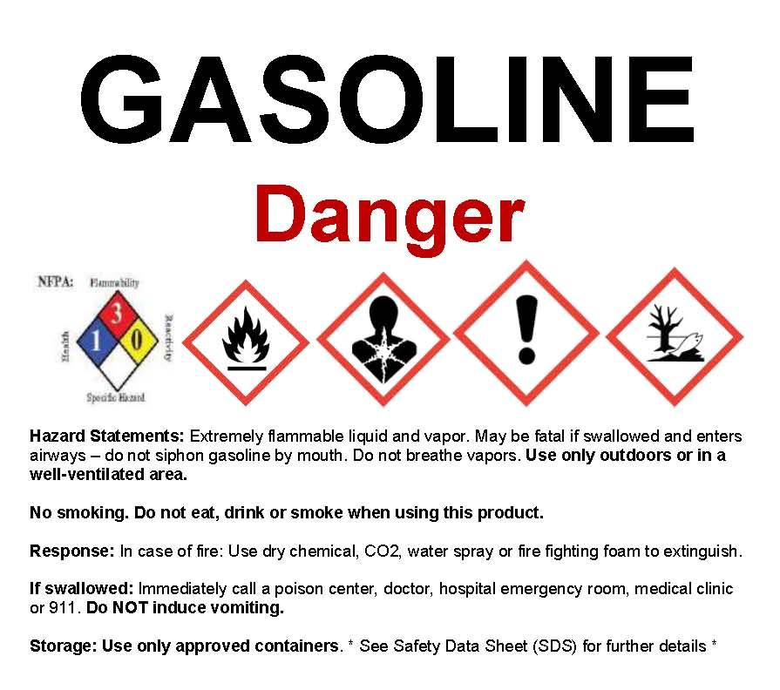

All workplaces where employees are exposed to hazardous chemicals must have a written plan which describes how the standard will be implemented in that facility. The plan does not have to be lengthy or complicated. It is intended to be a blueprint for implementation of your program--an assurance that all aspects of the requirements have been addressed. Keep a copy of this written plan in the MSDS binder or readily available in case of an OSHA inspection.

Present the Hazard Communication Standard new Safety Data Sheet format and labeling to employees as this month’s Safety Training topic. Following the presentation, have each employee sign a training log. Keep the monthly Safety Training Record on file (such as in the RED MSDS binder) in the event of an OSHA inspection.

Employee training on Hazard Communication will be a key factor in the success of your organization's implementation of GHS. The end result will be improved safety for workers via their awareness of the pictograms and other information provided on manufacturers' GHS SDSs and labels, in particular the necessary steps to protect people and the environment when responding to a chemical hazard.

The safety training should be based on U.S. Department of Labor, Occupational Safety and Health Administration (OSHA) standards, which require that personnel be trained on safety and environmental regulations at the beginning of their employment, and at least annually thereafter. Some basic topics to cover throughout the year include:

- Personal protective Equipment (PPE)
- Fire Extinguisher Safety
- Spill Clean Up Procedures
- First Aid Kit
- Eye Wash
- Forklift Operation
- Lifts and Hoists
- Cutting Torch Use

OSHA has concluded that effective management of worker safety and health protection is a decisive factor in reducing the extent and the severity of work-related injuries and illnesses. Effective management addresses all work-related hazards, whether or not they are regulated by government standards.

MSDS Library
http://www.sueschauls.com/MSDS.html

The MSDS Library at SueSchauls.com contains the Material Safety Data Sheets (MSDS) for all fluids that are evacuated from salvage vehicles plus some commonly used products. Check out the SDS for Gasoline to see the new format! The resource is available to all automotive facilities to help facilitate a comprehensive Safety Program. In the coming months and years through June 2016 when the conversion from MSDS to SDS is complete this library will be updated as SDS become available for automotive fluids and products.

Review and update your MSDS Inventory annually and on an ongoing basis. One of the best housekeeping jobs that can be conducted at the yard is to discard unused products especially those that have pulled out of a vehicle and are just collecting dust. Pre-loaded safety binders are also available for $25 by calling Sue Schauls at 319-290-7843 or email Schauls3@mchsi.com.

A monthly SAFETY SUBSCRIPTION is available for $199 per year to deliver training material via email each month to cover the important safety topic for an automotive salvage yard.

Sue Schauls is an independent environmental consultant with automotive expertise. She is the Executive Director & regulatory consultant for the Iowa Automotive Recyclers (IAR); she developed and implements the Iowa – Certified Auto Recyclers Environmental (I-CARE) Program. She contributes articles to several trade publications and is a member of ARA Technical Advisory, Safety and Affiliate Chapters and Certified Auto Recyclers Committees. She conducted nationwide outreach in the Mobile Outreach for Pollution Prevention for 13 years while at the University of Northern Iowa’s small business technical assistance program. Sue has a bachelors of Arts degree in Science: Environmental Planning from the University of Northern Iowa, 1996.

