NFPA 704 Hazard Rating System
By Sue Schauls

NFPA 704 Hazard Rating System a standard maintained by the U.S.-based National Fire Protection Association. It defines the colloquial "fire diamond" used by emergency personnel to quickly and easily identify the risks posed by nearby hazardous materials. This is necessary to help determine what, if any, special equipment should be used, procedures followed, or precautions taken during the first moments of an emergency response.

The National Fire Protection Association (NFPA 704) system uses a diamond-shaped diagram of symbols and numbers to indicate the degree of hazard associated with a particular chemical or material. These diamond- shaped symbols are placed on containers of chemicals or materials to identify the degree of hazard associated with the chemical or material.

The diagram identifies three color-coded categories of hazard for each material:

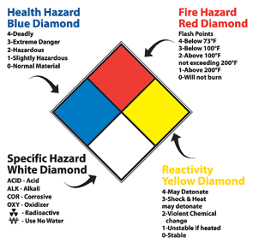
Health hazard (blue sections),
Flammability (red sections),
Reactivity (yellow sections), and
Other hazard information (white section).

Each category is divided in five levels of hazard potential with zero (0) used to indicate no special hazards and four (4) for severe or extreme hazard potential. The degrees of hazard in each of these categories are given as follows:

Health - The degree of health hazard of a chemical or material is based on the form or condition of the material, as well as its inherent properties. The degree of health hazard of a material should indicate the degree of personal protective equipment required for working safety with the material. A rating of 1 is for slightly hazardous (toxic) material that requires only minimal protection (for example, safety glasses and gloves) in addition to normal work clothing to work with safely. A rating of 2 is for moderately toxic or hazardous material that requires additional PPE or equipment (e.g. chemical goggles, lab/work smock, local ventilation) than required for less toxic material. Consult the MSDS for specific health hazard and proper PPE to use with this material. A rating of 3 or 4 is for highly to extremely toxic (deadly) material (and any carcinogen, mutagen, or teratogen [teratogen /ter·a·to·gen/ any agent or factor that induces or increases the incidence of abnormal prenatal development.]) These materials will require specialized equipment (e.g. respirator (or exhaust hood), full face shield, rubber apron, specialized glove, handling tongs, etc) beyond that required for moderately toxic material. You must consult the MSDS and/or other safety information to determine the hazard (acute or chronic) and the proper PPE and engineering controls to safely use of this material. Most of the automotive fluids evacuated from the salvage vehicles are Health Hazard Level 1. Batteries may be Level 3.

Flammability - The flammability hazards deal with the degree of susceptibility of the material to ignite and burn. The form or condition of the materials, as well as their properties, affects the extent of the hazard. Many hazardous materials such as acetone and gasoline, have a flash point (ignition temperature) far below freezing and will readily ignite with a spark if the vapor concentration is sufficient. A low rating of 1 is for material with a flash point above 200F while more hazardous ratings of 2, 3, and 4 are for materials with respective flash point below 200, 100 and 73 F, respectively. Most solvents and thinners have a flashpoint below 140F so have a Flammability Level 2 while diesel is Level 2 and gasoline has a Level 3 rating.

Reactivity - The reactivity hazards deal with the potential of a material or chemical to release energy. Some materials are capable of rapid release of energy without any catalyst, while others can undergo violent eruptive or explosive reactions if they come in contact with water or other materials. Generally this rating is used to indicate the potential to reactive if the material is heated, jarred, or shocked. A low rating of 1 indicates a material that is normally stable but may be reactive if heated. The more hazardous ratings of 2, 3, and 4 indicate a material is capable of violent reaction, shock/rapid heating and detonation respectively. Most automotive fluids have a Reactivity Level 0 while batteries are Level 2.

Other Hazard Information - An open space at the bottom of the NFPA diagram can be used to indicate additional information about the chemical or material. This information may include the chemical or material's radioactivity, proper fire extinguishing agent, skin hazard, its use in pressurized containers, protective equipment required, or unusual reactivity with water. For example, the usual signal to indicate unusual reactivity with water is the letter "W" with a long line through the center. Similarly the words ACID, COR (corrosive), RAD (radiation), OXY (oxidizer), Rad (radioactive), CARC (carcinogen) or other abbreviations may be used.

It is recommended that each container be labeled with the warning information.

Whether or not the building itself needs to be placarded with a 15 x 15 inch NFPA diamond depends on the volume of hazardous material stored within the facility. Lead-acid batteries have the highest Health rating 3 of any automotive hazardous material therefore if more than 100 pounds are stored inside a diamond warning is warranted or any amount stored in a room of the facility should have a diamond NFP warning sign to alert emergency personnel that corrosive acid is present and may pose a danger in an emergency response situation.

Gasoline has the highest Flammability rating of 3 therefore if more than 55 gallons are stored inside the facility then a diamond warning is warranted with a 3 in the top, red, flammability section. Likely gas and diesel are stored outside. For used oil and antifreeze with low rating of 1 more than 220 gallons would need to be stored inside to warrant posting the warning label on the outside of the building, which does seem likely. Each container should be labeled for clarification.

Placards shall be affixed to buildings or areas within the facility on each side where entry can be made at an appropriate height to be easily seen from approaching emergency equipment. A placard must be placed at the property line on a facility gate or post if a placarded building or area within a facility cannot be easily seen when approaching the property. Affix subdivision (room) placards next to access points into the room. These placards must be visible when doors into subdivisions are opened or closed.

USED OIL
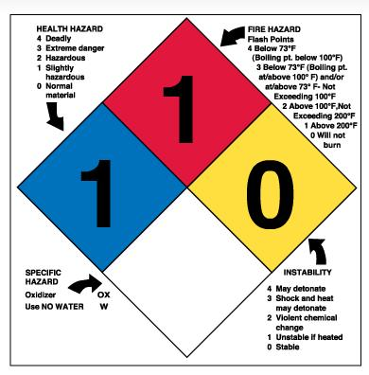

GASOLINE
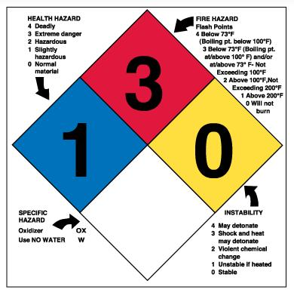

DIESEL
