GRAVELOLOGY
The three most important aspects of gravel retentions is drainage, drainage and drainage.
The science of gravel roads is one that civil engineers take seriously. In a recent webinar event form the STORMWATER magazine folks at Forrester Publishing made me wonder why we at the salvage yards are not tapping in to this vast amount of information on building and maintaining gravel road when we plan our yard layout and when adding gravel to the drive lanes.
Proper drainage is essential for a gravel driveway. Without it, water accumulates in ruts, creating a muddy, slippery surface that takes away from the overall beauty of a yard. Drainage options for a gravel driveway range from laying underground pipes through waterlogged areas to shaping the surface so water will naturally flow off property. Combining multiple solutions is the best way to ensure that your driveway will last for years with minimal maintenance.
Rock Layering
During installation, layering the gravel helps establish a strong, sturdy surface with enough gaps in the bottom for underground moisture to escape. For the bottom layer, use a 4-inch-thick layer of large gravel measuring over 1 1/4 inches in diameter. The second layer should be about 6 inches thick and laid with medium, 3/4-inch gravel. Use a mix of equal parts stone dust and small gravel for the 2-inch-thick top layer. Compact each layer of rocks, and always use angular, crushed rocks, as they stabilize when compacted.
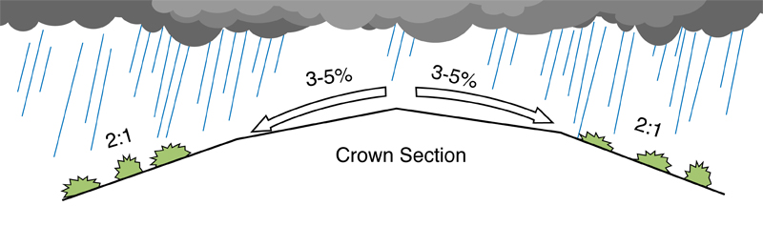
Crown
A simple way to improve the drainage of new and existing gravel driveways is to form the surface into a crown so the middle is about 2 inches higher than the sides. Use a rake to shape the gravel and compact it. Daily wear-and-tear makes tracks in the surface over time, creating spots where water can accumulate. Plan to replenish the surface with a new layer of small gravel and to reshape the crown every year or two. Avoid making the crown too steep, or vehicles will have a difficult time driving over the surface. Good drainage requires a crown of ½ inch per foot of each foot of width.
Prepare your gravel driveway for winter by getting a head start on erosion problems in the summer and fall, before the heavy weather hits. Gravel driveways require regular maintenance to ensure they stay in place during heavy thunderstorms. The trick to preventing erosion is controlling the water flow as it leaves the driveway. Once you control the water flow, direct the runoff where you want it to go. If you don't complete preventative maintenance before winter weather hits, you'll be in the rain making the corrections. Next year, enjoy the sound of the rain on the roof without worrying about an eroding gravel driveway. For more information visit www.GravelRoadsAcademy.com.

Sue Schauls is an independent environmental consultant with automotive expertise. She is the Environmental & Safety Consultant for CCAR-GreenLink the EPA automotive compliance assistance center. She is the Executive Director & regulatory consultant for the Iowa Automotive Recyclers (IAR); she developed and implements the Iowa – Certified Auto Recyclers Environmental (I-CARE) Program. She contributes articles to several trade publications and is a member of ARA Technical Advisory, Safety and Certified Auto Recyclers Committees. Sue has a bachelors of Arts degree in Science: Environmental Planning from the University of Northern Iowa, 1996.

