What is the Benefit of Attending an Industry Conference?

Much discussion is focused on the legitimacy of attending conference and trade show programs. The reality is that conferences are among the most cost effective methods of obtaining education and information, and in establishing a network.
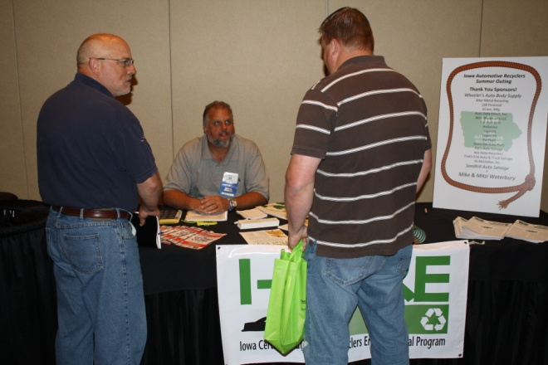
Conference sessions allow you to:
- Learn firsthand from industry experts that have successfully implemented technology solutions
- Keep up to date on new and emerging technologies
- Take the opportunity to create a professional network
- Create talking points to communicate more effectively with vendors
- Get immediate answers and solutions to issues within your business
- Discover new products that can decrease expense and increase revenue
Trade Show / Exhibition Events allow you to:
- See the latest in technology
- Hear new product announcements
- Visit all of your vendors in one location
- Get answers directly from vendors on the exhibition floor
- Do some comparison shopping
- Seek solutions and find new technologies
- Talk with others who are using or considering a product or service you are researching

