Pneumatic Tool versus Electric Hand Tool for Cost Savings
By Sue Schauls

Pneumatic tools are a regular part of the dismantling operations at auto salvage facilities. Air compressors are expensive to purchase and to use. “Right-sizing” is an important part of management. Downsizing the compressor to the job at hand can save money. A compressor running at part-load is generally less efficient than when it is running at full-load.¹

Compressed air management has become an industry of its own. There are compressed air training courses available and professional air management service providers. Air compressors use energy to generate pressure that frequently goes unused.

A compressor running at part-load is generally less efficient than when it is running at full-load.¹

The Illinois Sustainable Technology Center (ISTC) has a related fact sheet that may be helpful. The title is The Visible Cost of Air: A Worksheet to Assist in Identifying Compressed Air Saving Opportunities. It's available at http://www.istc.illinois.edu/info/library_docs/TN/tn07-087.pdf.² It will provide the user with a worksheet as a tool to identify cost saving opportunities in air management at a facility.
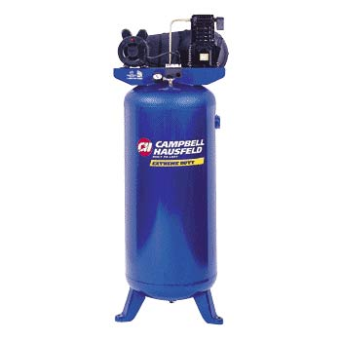
Another avenue of cost savings is to determine whether or not pneumatic tools are the right tool for the job. If a pneumatic tool is used infrequently yet the compressor runs continually, it may be prudent to replace the tool with an electric hand tool to reduce cost through energy conservation.
Stanley Tools developed a report and cost savings case study that indicates an electric tool can provide substantial savings.³

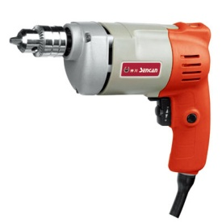

Annual savings with electric tools
There are many factors to consider when deciding which type of (dis)assembly tool to use for an application and many factors affect the total Life Cycle Costs of both pneumatic and electric tools. The example given here demonstrates the potential annual energy savings by using electric tools in place of pneumatic tools.

Assuming the pneumatic tool is used to fully tighten or loosen a fastener and that the air compressor continues to run even when the tool is not in use. Additional waste is added for the inherit leaks in a compressed air system. The calculation can predict the kilowatt hours used by an air compressor to run a pneumatic fastener tool. The cost can be calculated using a base rate of $0.06/ kilowatt-hour (about $213.48 annually for daily use). For comparison, the average electricity usage of an electric hand tool can be calculated for the fastening action as a “free-run” period that uses about 10% of the tools rated capacity and for the actual tightening action that uses about half the capacity. The sum of these two power usages is then multiplied by the same base rate of $0.06/kilowatt-hour to determine the cost of operating an electric hand tool to tighten or loosen a bolt (about $80.58 annually for daily use).

For this one typical application, the annual savings can be calculated as:
$213.48 - $80.58 = $132.90 potential annual savings by selecting the electric tool
Environmental impact
Green House Gas (GHG) gets a lot of press lately. GHGs drive climate change by creating a greenhouse effect when the sun’s rays are trapped within the Earth’s atmosphere. Most electricity is produced in coal-fired power plants in the U.S. This combustion process generates carbon dioxide (CO₂) emissions. CO₂ is a greenhouse gas. Reducing the energy consumption of the power tools used to disassemble threaded fasteners in a salvage yard will result in a global reduction in CO2 emissions.

From the cost savings calculations, the example pneumatic tool would use 3558 kilowatt-hours annually. The example electric tool would use 1343 kilowatt-hours for the same application. So the potential annual savings would be:
3558 – 1343 = 2,215 Kwh savings per year

Calculate the potential annual CO2 emissions reduction using known values as follows:
2,215 Kwh x 681g of CO2/Kwh x
0.002205 lb/gram ÷ 2000 lbs/ton =
1.663 tons of CO₂ reduction per year

These figures can vary widely for different countries and will depend on the local source of electricity. But it is clear that electric tool can provide a source for energy savings and a source for the reduction of CO₂ emissions into the environment.³

References
1 http://www.compressedairchallenge.org/ sponsored in part by the Iowa Energy center.
2 http://www.istc.illinois.edu/info/library_docs/TN/tn07-087.pdf.
3http://www.stanleyassembly.com/documents/en/White%20Paper%20on%20Energy%20Consumption.pdf

About the author: Sue Schauls is an independent environmental consultant with automotive expertise. She is the Iowa Automotive Recyclers Executive Director & I-CARE Program Manager and the CCAR-Greenlink Technical Advisor.

